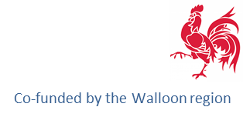

Landfill mining ambassador

Stimulating and Promoting widespread use of RAWFILL outputs

The focus of RAWFILL is on supporting a new circular economy for RAW materials recovered from landFILLs in the North-West Europe (NWE) region. In order for landfill mining to be widely implemented in this region LFM ambassadors, who received training by RAWFILL partners about the innovative landfill characterisation (coupling geophysical imaging and guided sampling) as well as its multi-criteria decision support tool for prioritising landfills, are needed.

Training of ambassadors comprised the following aspects:

- Enhanced Landfill Inventory Framework (ELIF)
Stakeholders can estimate the economic potential of landfills by applying the ELIF.

- High-performance and cost-effective landfill geophysical methods
Demonstration of a multi-method geophysical approach for characterising landfills through large-scale non-invasive surveys reducing pre-screening costs.

- Ranking landfills by a multi-criteria decision support tool (DST)
Prioritisation of landfills according to economic and ecologic viability in order to implement landfill mining projects at a regional and transregional level.

- Site visit at a landfill
Geophysical data acquisition on site.

I hereby acknowledge the objectives of RAWFILL and will be pleased to promote landfill mining for the benefit of its wide implementation in North-West Europe.

__________________________________________
(Name)

__________________________________________
(Organisation)

__________________________________________
(Place, Date, Signature)

